**Introducing Order Capture**

With Industries CPQ's **order-capture**capabilities, you can ensure **accurate orders** on the way to submitting the **perfect order** for the customer. Industries CPQ enables you to design and apply business rules to ensure that products and services presented for customers to buy are:

* Available to the consumer or business account.
* Items for which the customer is eligible.
* Priced accurately.
* Compatible with any existing products and services held by the customer account.

# How Industries CPQ Order Capture Solves Business Challenges

**Business Challenges with Order Capture**

* **The order fallout challenge:** Companies strive to offer products across different channels, based on the same enterprise product catalog data, finding it difficult to provide accurate, consistent quotes. This can mean order fallout and lost business.
* **The slow-to-sell challenge:** Sales teams spend too much time quoting product prices when they could be making sales. This results in high operational costs and wasted resources.
* **The customer-satisfaction challenge:**Customers demand rapid quotes for best-fit products that take into account their eligibility and personal preferences. If customers don't get what they want, they shop elsewhere, meaning lost business.
* **The product-complexity challenge:** Companies often have numerous and complex products, with a large number of product incarnations possible. If product offers and business rules aren't configured correctly, the result can be order fallout and lost business.

**How Industries CPQ Solves the Challenges**

The order-capture capabilities of Industries CPQ let you to meet the business challenges by **controlling the selling process** using the Cart and an **asset-based** ordering system. Customer service representatives (CSRs) and sales teams can perform a variety of business tasks through **guided selling** to capture the **perfect customer order**. The product-service-resource (PSR) data from the Enterprise Product Catalog (EPC), the master product catalog, underpins the Industries CPQ solution with a shared, central single point of truth for all PSR data.

* **Challenge:**  Order fallout
  + **Solution:**Offer products across channels based on highly configurable, accurate, and consistent quotes.
* **Challenge:**Slow sales
  + **Solution:** Equip and guide sales teams to sell the right products quickly to customers.
* **Challenge:** Unsatisfied customers
  + **Solution:** Enable the easy and fast creation of accurate quotations based on best-fit products for customers.
* **Challenge:** Product complexity
  + **Solution:**Ensure valid product offers based on business rules, such as availability, eligibility, and customer context.

# The Order-Capture Flow

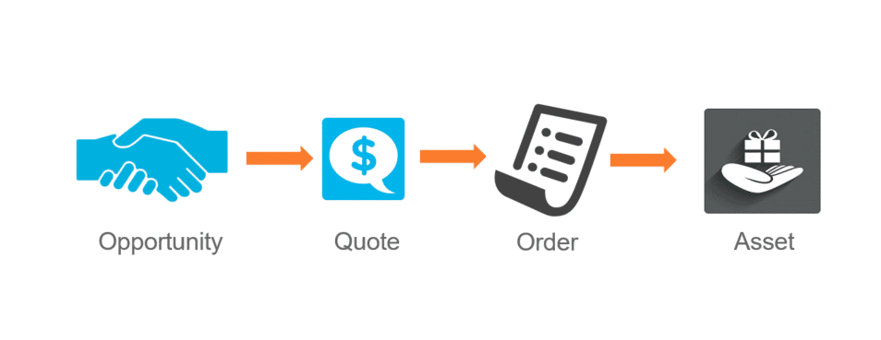

Industries CPQ extends the native capabilities of Salesforce to provide comprehensive management of the order-capture flow. Opportunity, Quote, Order, and Asset are standard Salesforce objects. The two types of process flows include:

* **Business to business (B2B)**, which starts in a business account.
* **Business to consumer (B2C)**, which starts in a consumer account.

Use your Salesforce Industries Cloud applications to define and manage process flows to determine what you can offer to customers.

# The Cart

The **Cart** is the shopping-cart UI provided out-of-the-box with your managed package. Developed using the **Vlocity Card Framework**, you can modify the appearance and behavior of the Cart to customize it according to your specific business requirements. The Vlocity Card Framework provides configurable **cards**, **layouts,**and **templates**, which are UI building blocks included out-of-the-box with Industries CPQ.

**Cart Technology**

* Built on the Salesforce platform
* Salesforce-Lightning-Experience ready
* Provides an open architecture and extensible framework
* Based on Angular JS, HTML 5, and SMACSS

**Overview of the Cart UI**

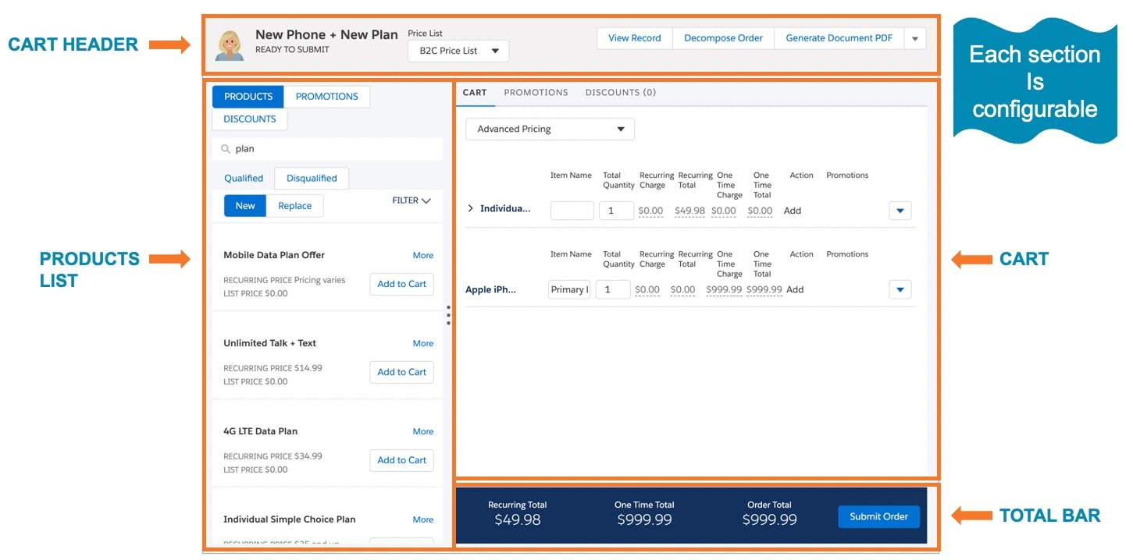

**Basic Layout**

The Cart gives you a cards-based UI that includes the following main areas:

* Cart Header
* Products, Promotions, and Discounts lists
* Cart View and Total Bar

**Cart Header**

The **Cart Header** shows the account, order, quote, or opportunity name, relevant price list, and OmniStudio Action buttons. The Cart uses price lists and rules to determine which products to display.



**Products List**

In the Cart, the panel on the left displays the **Products** list which includes the Products, Promotions, and Discounts tabs. Price lists and rules determine which products display in the Products list. Remember, you only want to show products that are available to the customer and products for which the customer is eligible. The **Qualified** tab displays items that you can add to the Cart for the customer. Whereas, the **Disqualified** tab lists any items that cannot be added to the Cart due to unavailability or customer ineligibility.

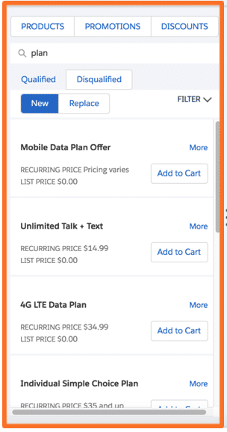

The **PRODUCTS, PROMOTIONS, and DISCOUNTS**tabsdisplay the products, promotions, and discounts available to the customer.

**Cart View and Total Bar**

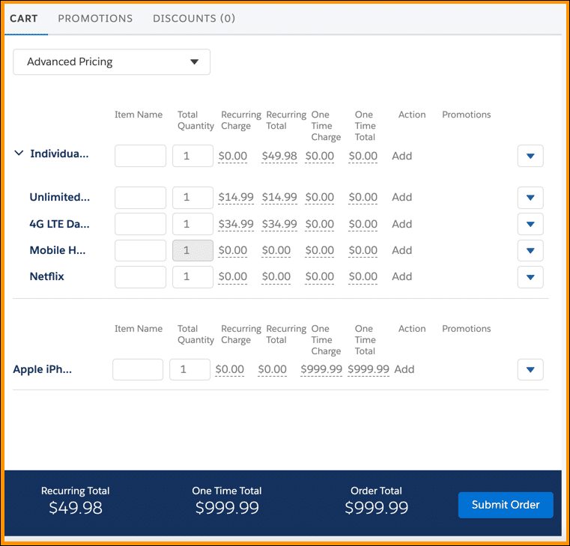

* The **Cart View** shows the items in the shopping cart as order line items. In this view, you can configure products and services as needed by the product definition.
* The **Total Bar**shows the total price for items in the Cart area, including one-time charges and recurring charges.

**OmniStudio Actions**

The Cart's OmniStudio Action buttons are customizable for each implementation, enabling you to implement buttons for a variety of different order-capture tasks.

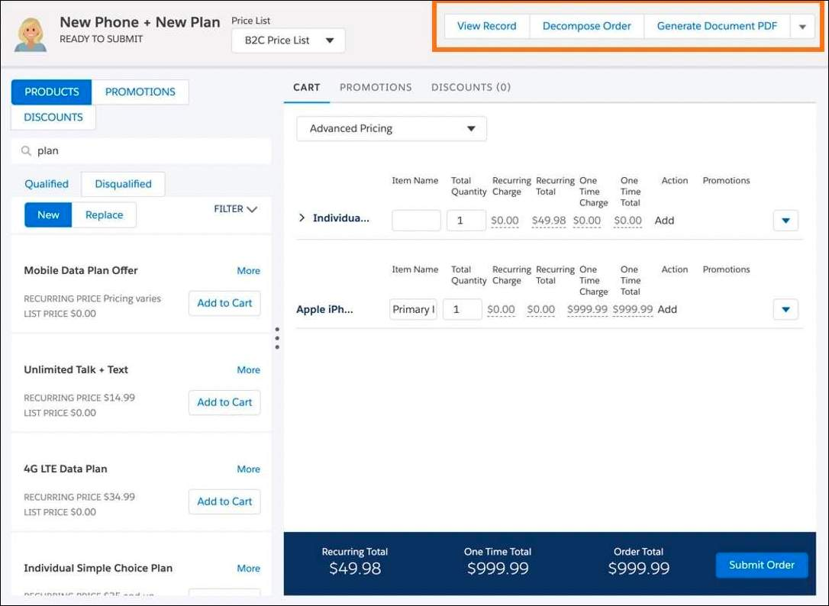

**Cart View: CART, PROMOTIONS and DISCOUNTS Tabs**

Now, you'll take a closer look at the Cart, Promotions, and Discounts tabs in the cart area. In the example shown below the CART tab shows all the line items added. As you expand the items you can see the product hierarchy including parent and child items as structured in the Enterprise Product Catalog data model. The Promotions and Discounts tabs display any promotions or discounts currently applied to the line items. With the CART tab open, use the drop-down menu to show either the **Basic**view or the **Advanced Pricing** view.

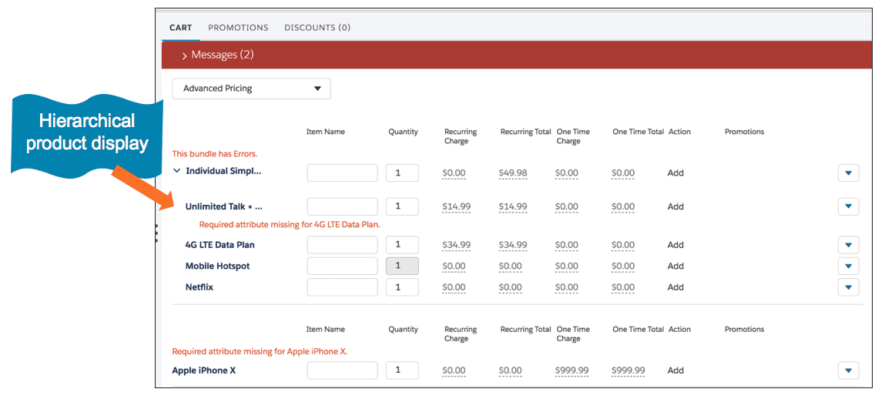

* The **CART**tab shows all items in the cart.
* The **PROMOTIONS**tab shows any promotions currently applied to the cart line items.
* The **DISCOUNTS** tab shows any discounts currently applied to the cart line items.

**Working with Line Items**

From the Cart view, you can work with order line items in a number of ways though the related drop-down menu.

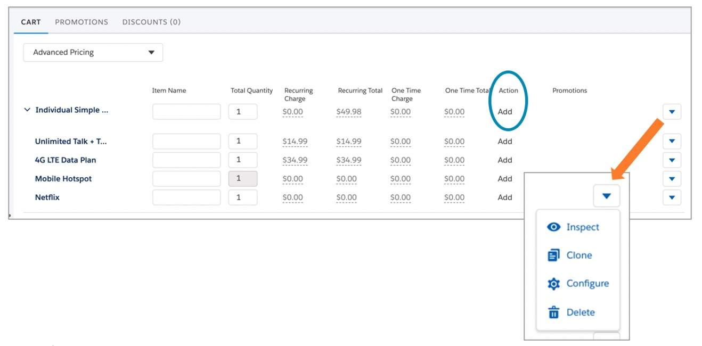

* **Inspect**: Takes you to the line item details.
* **Clone**: Creates a copy of the item that you can customize to re-purpose.
* **Configure**: Opens the configuration window for the item.
* **Delete**: Removes the item from the Cart.

# Ensuring the Perfect Order

**Introducing Rules**

Industries CPQ uses rules to ensure that every order is an accurate order.

Rules filter products to ensure that:

* The right products and promotions are shown as available to customers at the right price.
* The appropriate penalties for product or service changes and cancellations are assessed in line with business objectives.
* Every order is a perfect order.

**The Right Products and Promotions**

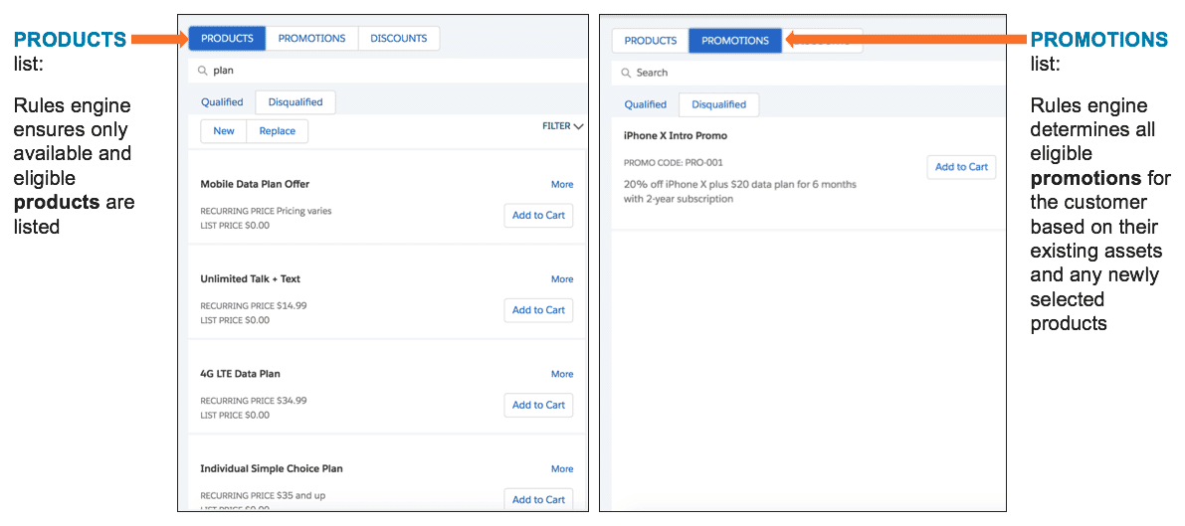

**The Right Configuration**

Business rules, such as compatibility, configuration, and validation rules, verify products for compatibility and price.

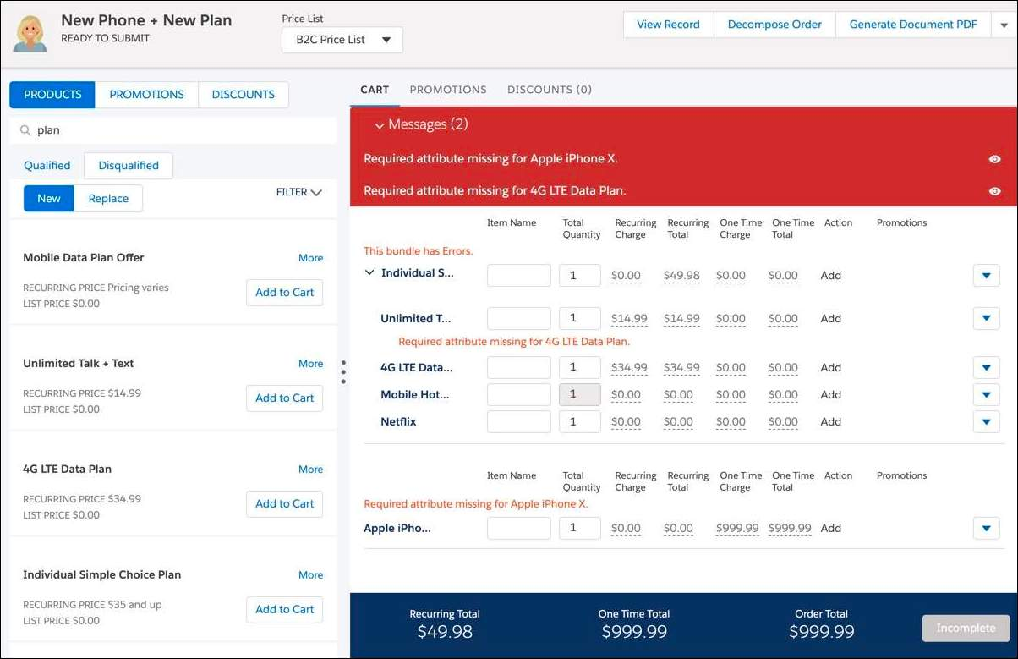

**Take-Me-There Support**

With take-me-there support, you go directly to the required configuration to prepare the order for submission.

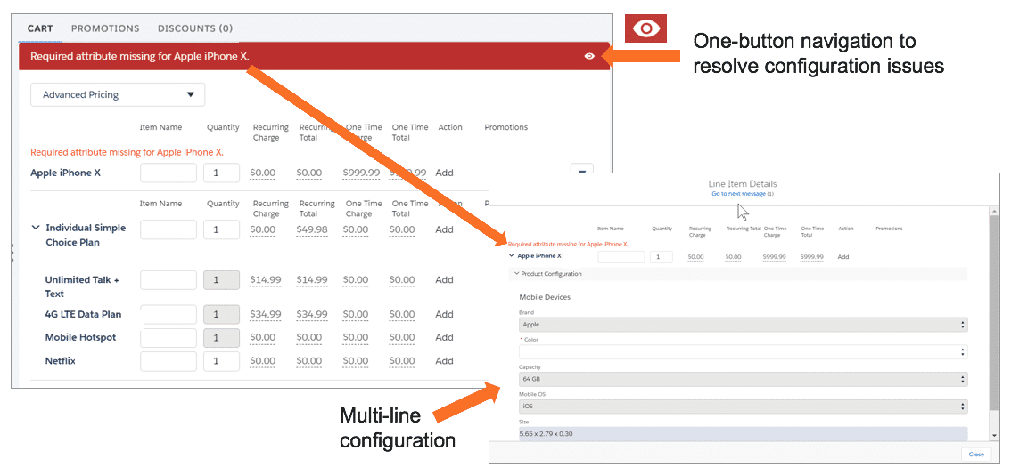

**Validation Before Order Submission**

Configurable validation ensures that you can only submit the order after all configuration is provided. The **Submit**button remains disabled and shows "Incomplete" until the order is valid.

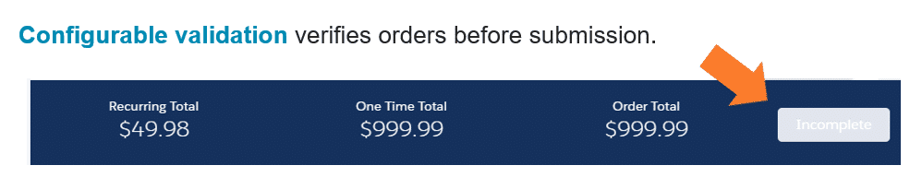

**Ensuring the Perfect Order**

Rules help make sure each order is perfect. Two rules frameworks operate in tandem to filter the product list so that the list is 100% applicable to the customer. The product list starts with the Enterprise Product Catalog (EPC) and moves to the Context Rules Framework, which filters the product list further. Next, the Advanced Rules Framework refines the list as needed and presents all the available and eligible products and promotions in the Cart.

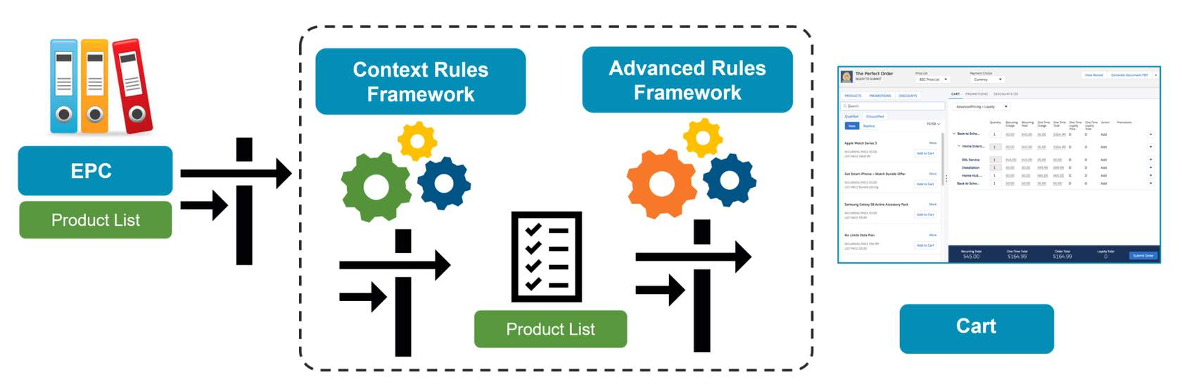

# What's an Asset?

* An asset is an item of value that an account or contact owns. You may know assets as products or services in a customer portfolio.
* In Salesforce, assets are products or subscribed services captured during the order-capture process.
* Asset-based ordering takes into account the existing products and services of a customer.
* Salesforce Industries extensions to the asset object support discounts, special pricing, and customer preferences.
* Whether an asset is created right away or later depends on the defined order-management process flow.

**Asset-Based Ordering**

Using asset-based ordering, Industries CPQ lets you manage products and services throughout the concept-to-care process. Standard ordering systems end the customer relationship once the order is complete. However, not all orders are about buying new products or services. For example, a customer may want to modify their assets by:

* Adding a service, for example, to enable international roaming from a smartphone.
* Adding a product, for example, to add another smartphone to a family phone plan.
* Updating a service, for example, to change the internet speed for their residential broadband service.
* Disconnect a service, for example, to cancel a cable service.

# Asset-Based Ordering

**Introducing Asset-Based Ordering**

Many customer orders impact products and services that the customer has already purchased. Salesforce Industries applications extend general order-processing capabilities to manage the products and services of customers throughout the order-capture lifecycle.

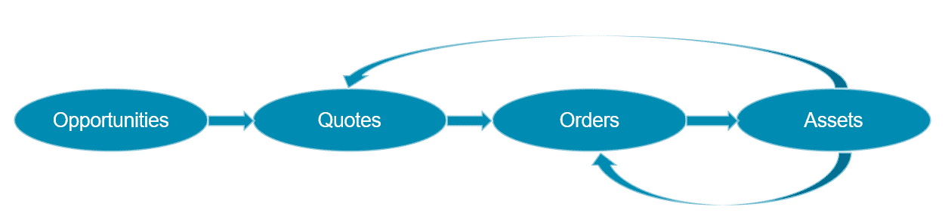

Customers may want to change their assets in a number of ways. Specifically, they may want to:

* **Add a service**, for example, to enable international roaming with a wireless plan.
* **Update an existing service**, for instance, to increase internet speed from 25Mbps to 50Mbps.
* **Disconnect a service**, such as to cancel a cable subscription.

**Customer Lifecycle and Reverting Assets**

1. Customer Lifecycle

* In the first stage of order capture, an opportunity moves to a quote and then to an order.
* In the next stage, with completion of the order, the order becomes an asset.
* At some point, you may need to revert the asset back to order status, namely if the customer wants to change the asset.

1. Reverting Assets

The option to revert assets is an out-of-the-box capability. You may need to revert an asset six months, one year, or two years after the customer bought the initial product or subscribed to the original service, for instance, if they want to change a service. This may include a location change if the customer moves residences.

In this case, you need to update the existing asset with the new details, as opposed to creating a new asset. Otherwise, the customer will have two of the same assets, which can cause data ambiguity.

Updating the existing asset enables retention of service continuity for the customer and avoids faults that may occur through unnecessary provisioning of additional assets.

1. Examples in Context

**Basic Example:**

1. A customer with a residential account wants to change a broadband internet service from 25 to 50 MB.
2. The customer calls their service provider, who moves the broadband internet service asset back to an order and changes the configuration.

**Advanced Example:**

1. A customer with a commercial account wants to change a B2B service from Gold to Platinum level.
2. The customer calls the service provider to request the change.
3. However, the service provider finds that the service upgrade requires approval by someone else in the company.
4. In this case, the service provider reverts the asset to a quote in preparation for the change process.

**Asset-Based Ordering**

Industries CPQ supports the creation of quotes and orders against a set of customer assets. In all cases of asset-based ordering, you change an existing asset by moving it to either:

* **A quote**, and once the quote is complete, move the quote to an order, and then an asset, or
* **An order**, and once the order is complete, move the order to an asset.

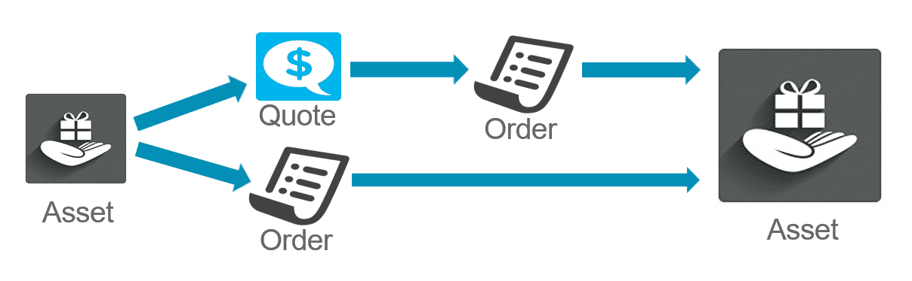

**Service-Asset Management**

From the quote or order, you can make changes to the asset structure.

* A customer calls into the contact center, and you view the customer account.
* You can see all the customer assets, whether from the standard Salesforce screens or from customized Cards on the console.

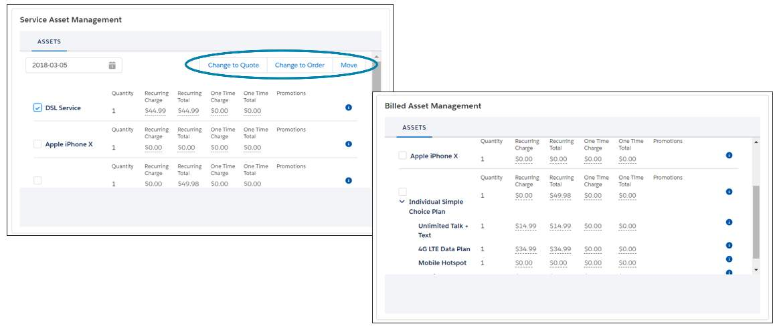

**Order Line Item Status**

To help you work with assets, the Cart shows you the current lifecycle status of order line items.

For instance, in the screen capture below you can see that Home Networking Service has been added and Netflix has a disconnect. This status information is essential for the order management system that receives the order so the system can carry on with processing the order

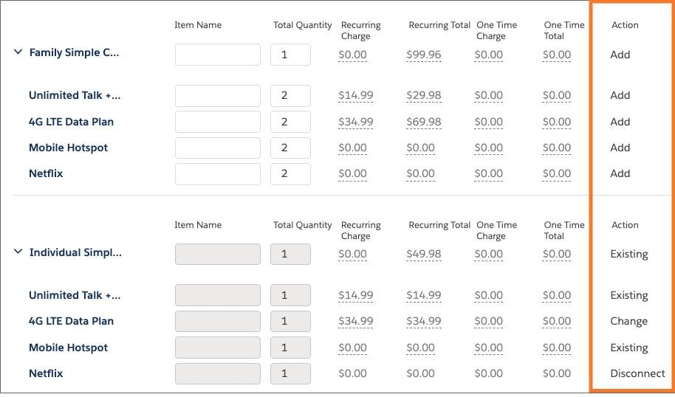

* **Add**: Order has been placed, but the product or service is yet provisioned/activated.
* **Existing**: An existing asset. No changes have been requested.
* **Change**: A change has been requested.
* **Disconnect**: A request has been made to end the product or service.
* **Suspend**: A request has been made to temporarily halt the service.
* **Resume**: A request has been made to reinstate the temporarily halted service.

# Introducing Order Cancellation

Industries CPQ and Industries Order Management (iOM) work together to support:

* **Canceling part of an order**
* **Canceling the entire order**

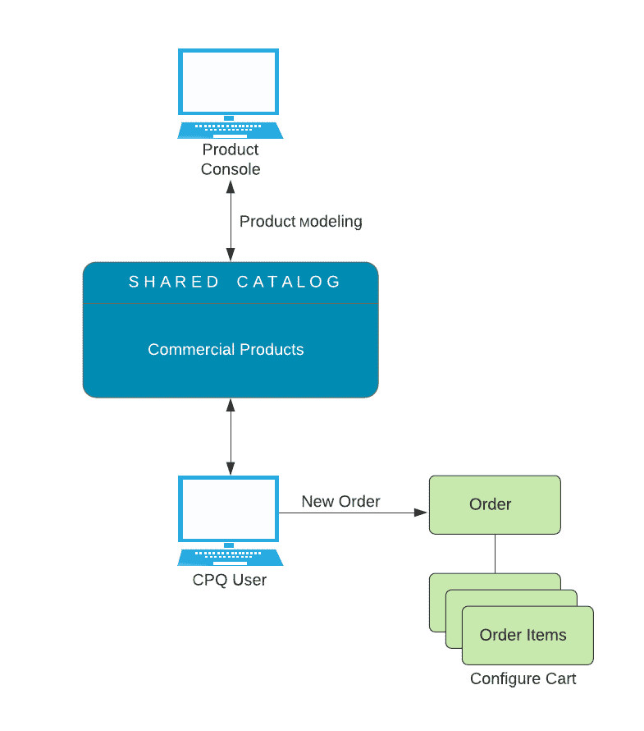

The process flow diagram above shows the order capture process without order cancellation.

Some basic orders complete immediately. Other orders are more complex, and some period of time elapses from the time the order is captured until it is fulfilled. For example, a home internet package that requires shipping out a router from a warehouse and scheduling an on-site technician to configure it for the customer after it arrives.

So, completing an order could take seconds, minutes, days or even weeks!

**Q.)** What if a customer places an order, but needs to cancel it before it has completed?

**A.)** That requires Industries Order Management (iOM).

**Introducing Industries Order Management (iOM)**

Generically speaking, order management brokers the data required to fulfill the products and services on an order.

Industries Order Management does this through two processes:

* **Decomposition** - Maps commercial products to technical products
* **Orchestration** - Communicates technical information with downstream fulfillment systems

**Commercial products are what the customer sees and understands, such as phones and home internet packages. Technical products contain the information fulfillment systems need for billing, provisioning, activation, etc. Customers are shielded from the details of technical products. (They don't understand or even care about details such as freeing up port resources in order to receive home internet.)**

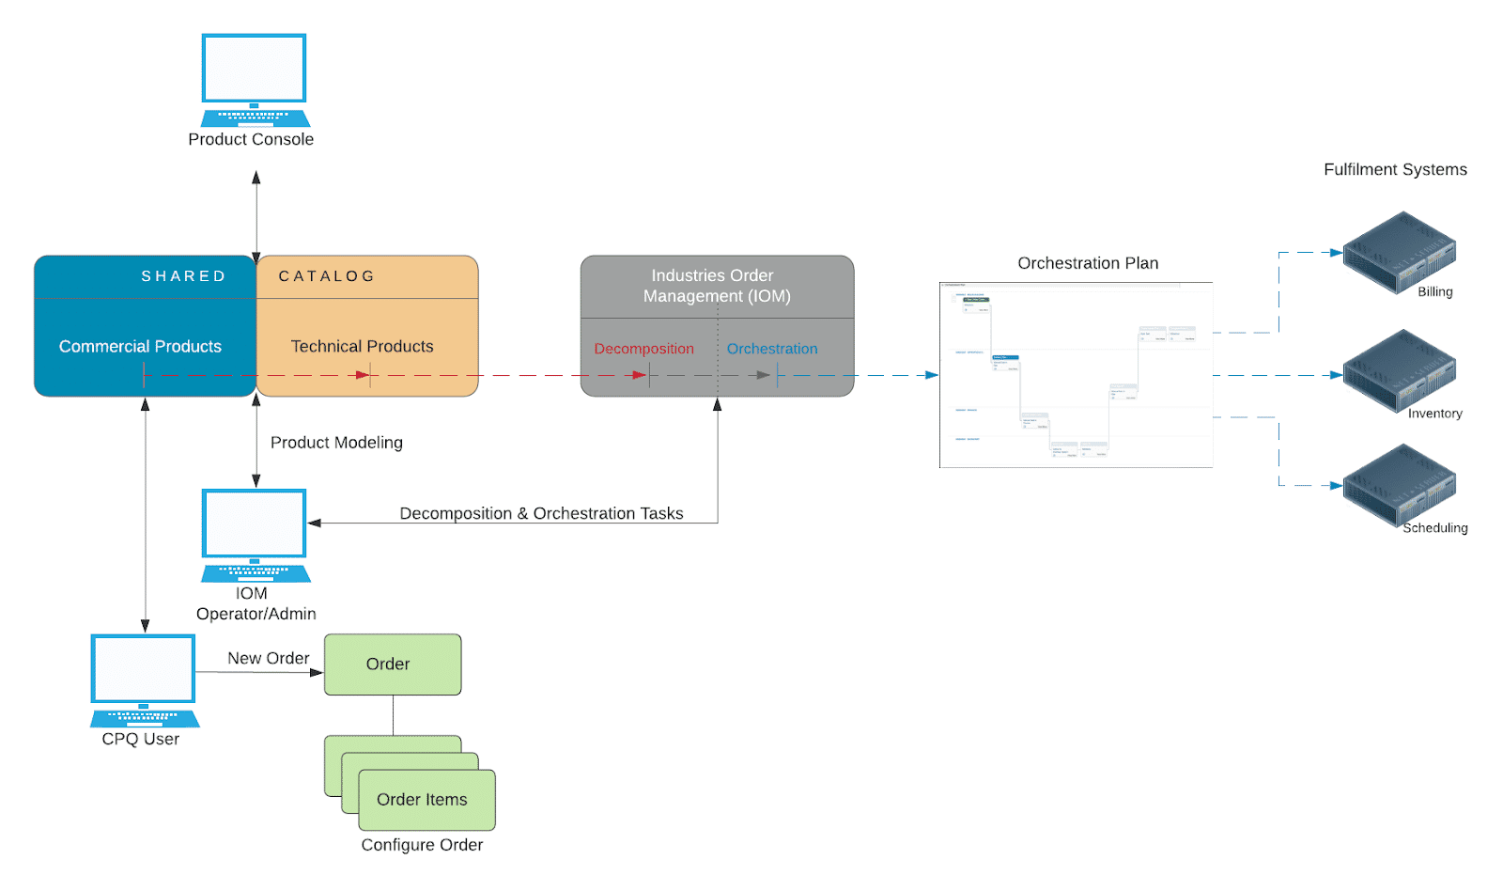

# Order Cancellation and Status

**Terminology**

A basic understanding of the following new terms is important when learning order cancellation and the communications between Industries CPQ and Industries OM.

* **In-flight order -**An order that has been submitted (from CPQ to iOM) but not completed.
* **Supplemental order -**An order created by Industries CPQ to revise an in-flight order. Supplemental orders supersede the original in-flight order.
* **Point of no return (PONR)**- Point in the order orchestration process that once passed, order cancellation is no longer possible or permitted.

**Status**

There are several different types of statuses worth noting for those needing to understand the order cancellation process.

**Salesforce Status**

New orders use the Salesforce Status field. It has two picklist values by default: **Draft**and **Activated**.

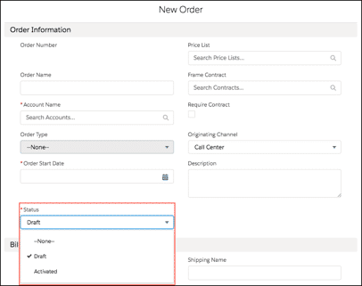

**Industries Order Status**

Industries CPQ and Order Management orders require additional functionality to implement functions such as order cancellation. Enter the Order Status field. The default view of the Orders tab provides an excellent snapshot of key order status fields. Note the status fields are shown for both the original in-flight order and the supplemental order used to implement order cancellation. Lastly, note that the supplemental order is associated with the original in-flight order via the entry in the Superseded Order column.

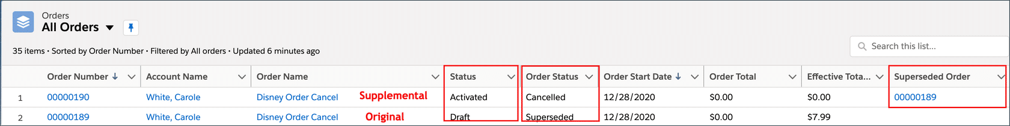

**Orchestration Status**

Orchestration Plans and the individual tasks that comprise them have states as well. The following is a simple executing Orchestration Plan made up of three individual tasks. (OC2 Start, OC2 Pause, OC2 Stop)

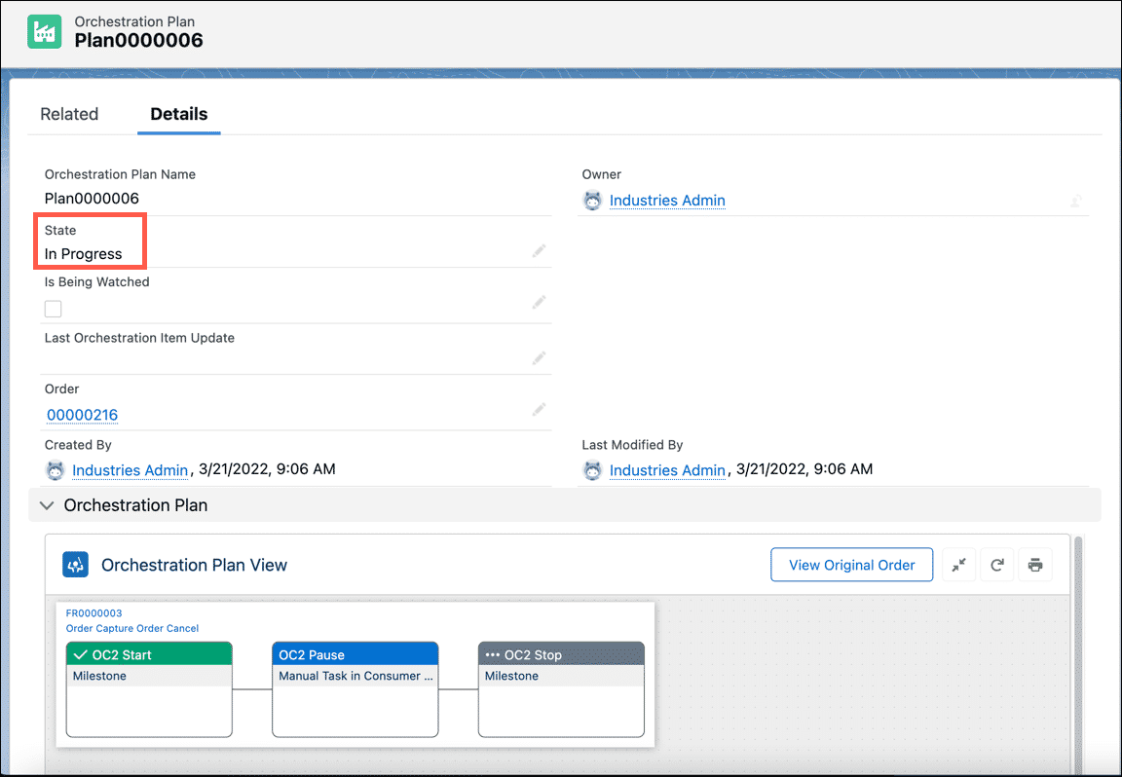

Industries Order Management makes it simple to see the states at a glance. Notice the following from the example plan shown above:

* The **State** of the plan itself is "In Progress". Another common state is "Completed".
* The **Status**of the individual tasks are color coded:
  + **Completed** (OC2 Start)
  + **Ready** (OC2 Pause)
  + **Pending** (OC2 Stop) - The task is ready to run, but has not started yet. (It is waiting on a task dependency to complete before it can start running.)
  + *Note*: When you hover over a task, the status is displayed.
* There are two other common states for order cancellations that are not shown above:
  + **Cancelled** - Task that was canceled.
  + **Discarded** - Task that has not been executed when a supplemental order required that it be canceled. The task will not be executed.

**Industries CPQ and Industries OM Communications**

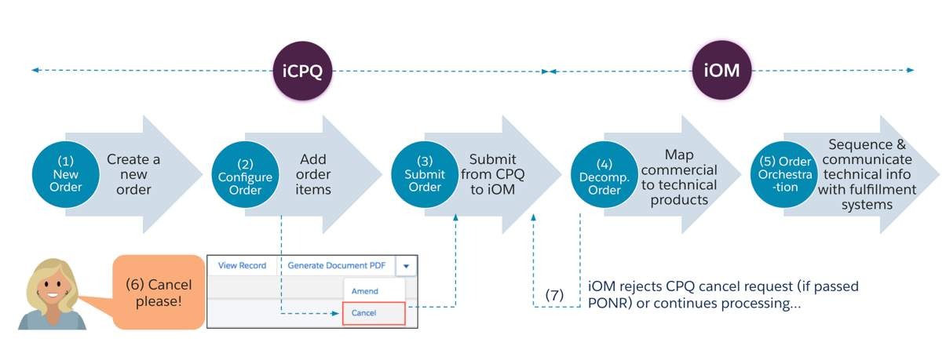

# Quotes and Asset-Based Ordering

**Working with Quotes using Industries CPQ**

A**Quote** represents the proposed prices of your company's products and services. In standard Salesforce, you create a quote from an opportunity and its products, and they can be viewed in the Quotes tab. Using Industries CPQ, you can also create quotes from an asset as a part of the asset-based ordering process. This is typically done as part of a B2B sales process, but it can also be done in B2C.

**Change to Quote Action Button**

In the asset management layouts, you can select one or more assets, and then click **Change to Quote**. This action button launches the CPQ Create Quote OmniScript, which creates a new quote for the selected assets and opens the quote in the Cart. Once the quote is opened in the Cart, all of the applicable Industries CPQ rules and pricing will be enforced. The line items that were created from the assets will have a status of "Existing".

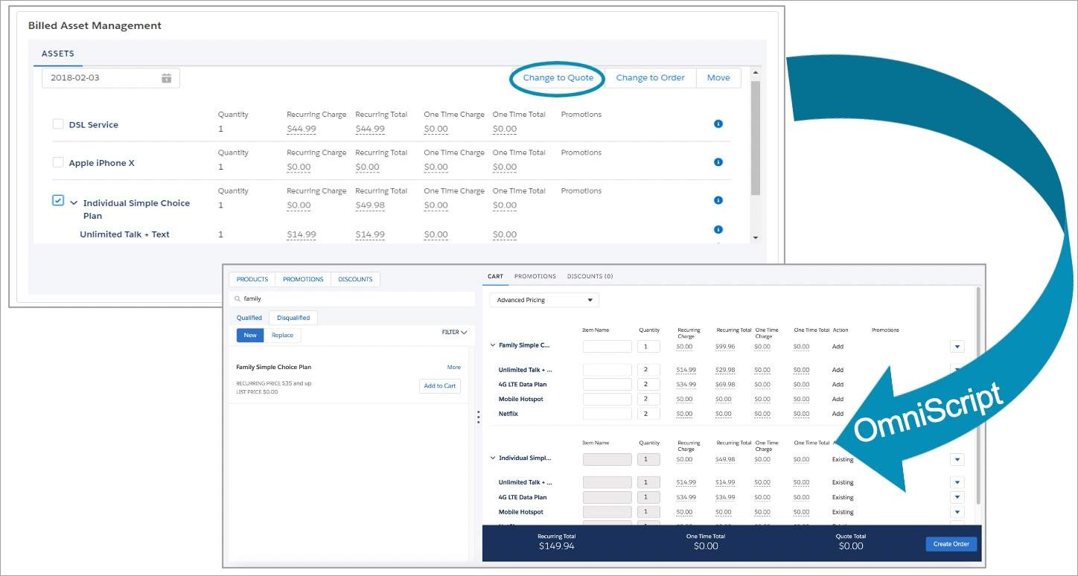

# Customizing Action Buttons in the Cart

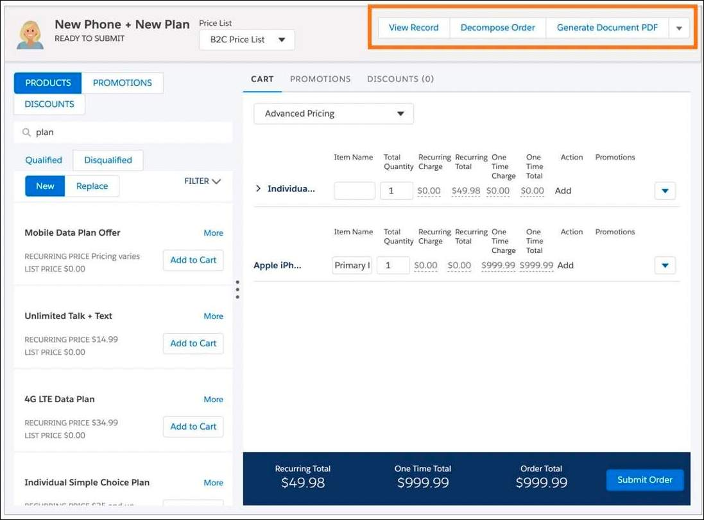

In the Cart, the Cart header for Opportunities, Quotes and Orders displays several action buttons. In your deployment, you may want to customize these actions to provide functionality that is important for your business process. You can do that by creating new OmniStudio Actions and adding them to the cart header card (cpq-header).

# Field Mapper

Field Mapper is a declarative mapping tool that provides simple, extensible, and comprehensive capabilities for transforming objects in the order-capture lifecycle.

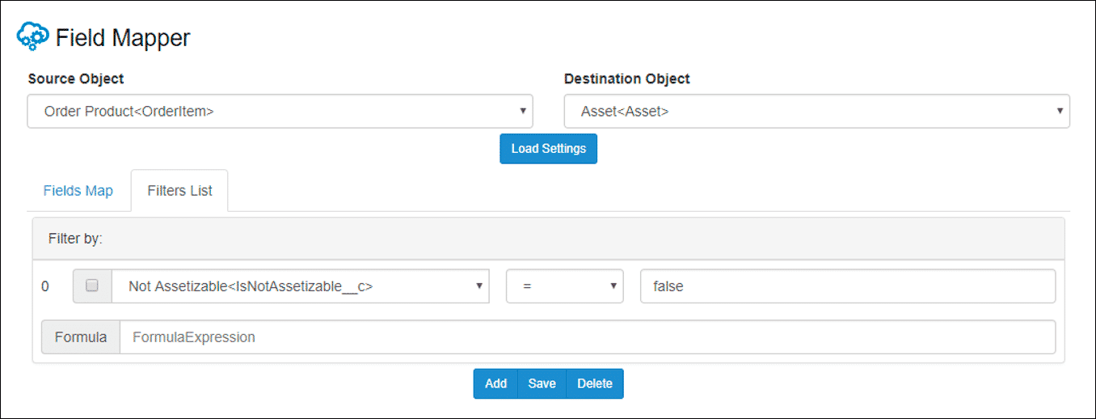

In the context of commercial assetization, you can use the Field Mapper to specify the conversion of the following objects:

* Opportunities to quotes
* Quotes to orders
* Orders to assets
* Assets back to orders
* Assets back to quotes

You can use the Field Mapper to create a filter that keeps not-assetizable products from being assetized. Namely, the filter specifies assetization only when the Not Assetizable option is un-selected. Filters allow you to limit source fields based on specified conditions. Filters are inclusive, and you can define the conditions in a formula expression. If a formula is not indicated, the Field Mapper joins the filters using an AND statement.

Without the use of the Field Mapper, you would need to write transformation code to perform the conversions.

# Commercial Assetization

**Commercial assetization** is the act of setting a product as assetizable, which means that the product is tracked as an asset in the customer account. Typically, only products of a certain value are considered assets. For example, a company may not want to keep track of promotional items, such as a promotional hat or pen with the company logo.

* Within Salesforce Industries applications, you can designate commercial products as **not assetizable**.
* Commercial assetization stores instances of commercial products in Salesforce, creating a snapshot of the products or services the customer has purchased.
* Commercial assetization is different from **technical assetization**, which stores the output of decomposition in the technical inventory of Industries Order Management.

**Deciding Whether or Not to Assetize a Product**

**Why set a product as not assetizable?**In a nutshell, if you don't want to track the commercial value of a customer asset,  you should configure the product as not assetizable. The example screen below shows the **Not Assetizable** option in the product configuration for an iPhone case in the Product Console.

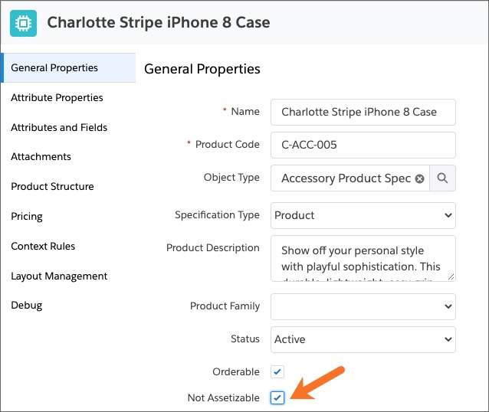

As part of the managed package, Salesforce Industries includes a Not Assetizable field on products. However, the same field is absent from Order Products, which are order line item sObjects. Because of this, you need to create the Not Assetizable field manually on Order Products if required.

In this case, you add the Not Assetizable field to Order Product, as shown in the next section. Then you use the Field Mapper to ensure that products that are marked as "Not Assetizable" are not created as assets during the order-capture process.

**Not Assetizable Custom Field**

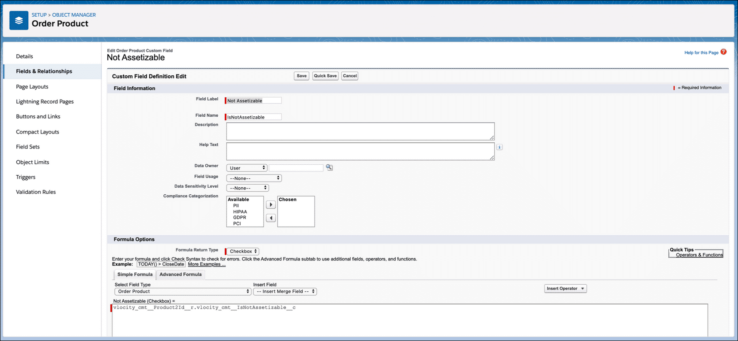

**Configuration Details**

The **Not Assetizable**field is a custom field that you set up on the **Salesforce Edit Order Product Custom Field** page, where you provide the following values:

* In Field Information:
  + Field Label: Not Assetizable
  + Field Name: IsNotAssetizable (using Pascal case)
* In Formula Options:
  + Formula Return Type: Checkbox
  + Not Assetizable (Checkbox) =: vlocity__cmt__Product2Id_r.vlocity_cmt__IsNotAssetizable__c